Editorial shoot submission form (2 pages)

[see separate guidelines for real weddings - this form is for styled photoshoots only]

IMAGES:

Please send me a link to a Dropbox folder containing 60ish of your most beautiful, bloggable images. Email the link to contactenglishwedding@gmail.com

Images should now be 2000px wide (not longest edge! Even portrait orientation images need to be this width)

Please complete all the information on this form and save it in your Dropbox as a Word or Pages document.

_______________________________________________
What should we call your shoot?

e.g. “Modern English Country Garden wedding inspiration from Yorkshire”

How should we introduce your shoot?
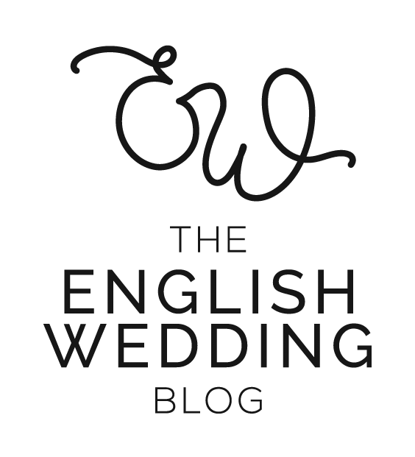
e.g. “This is festival wedding style taken to the next level! We styled an incredible backdrop and made the most of the natural surroundings at [venue]. Our brides are a real couple, dressed in stunning separates by [designer]. The florals are amazing - [florist] took our breath away with his playful use of colour and texture…

Add as many paragraphs as you like here - we’ll copy and paste it onto the blog.

Supplier WEBSITES
Format: https://english-wedding.com
Paste your list here

Supplier INSTAGRAMS
Format: @englishweddingblog
Paste your list here

Supplier EMAILS
Format: contactenglishwedding@gmail.com
Paste your list here

What happens next
I reply personally to every submission I receive. It can take a little while, so please give me 3 weeks before you check if I’ve seen your submission - thank you :)

If your submission is accepted, I’ll email you to confirm the publication date so you can put it in your calendar.

Please!
Ask all the suppliers to share the feature when it’s published on English Wedding.
Tag @englishweddingblog on instagram and use our hashtag #englishweddingblog
Interact with our instagram posts - leave a comment, save the post, share to your Stories
Use the Pin icon on our blog post to share your favourite photos to your Pinterest

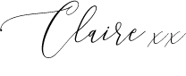
Thank you!

